MARYLEBONE HEALTH CENTRE
PATIENT PARTNERSHIP GROUP AGENDA
^{22nd June 2026 6pm-8pm}

1.Welcome Chair JM
Apologies & Chair’s introduction

2. Minutes of last meeting Chair

3. Matters Arising Chair

5. Cora Health – they cancelled and booked to attend 3rd august

6. Practice update JC
A) Staff changes
C) New services -CRM
D) Feedback re St Charles Minor Injury unit
E) Drs Strikes/or not!
F) Recent complaints:
PT saw a GP who referred her to Gyny @ Imperial. They booked her colposcopy clinic which she didn't expect-and she said GP assured her this would NOT happen
PT given an infusion at Hospital and told to come back for blood tests- iron tests not requested by GP so nurse took alternate tests and PT upset because she did not consent to the tests being taken
Dr saw PT and he thought maybe intoxicated –pt unhappy its in notes
Not complaints but interesting learning-PT prescribed statins and untoward effects. Discussion about how we consult with patents

g) F and F update May 2026 -see below
Changes/actions from previous feedback- Gp's preparing for consultations and lift maintence

5. Stakeholders JM and BH
Health watch and PCN PPG
6. Immunisations plan SF

7. Event Planning and work plan for PPG 2026/2027 JM
Children events May feedback
Newsletter
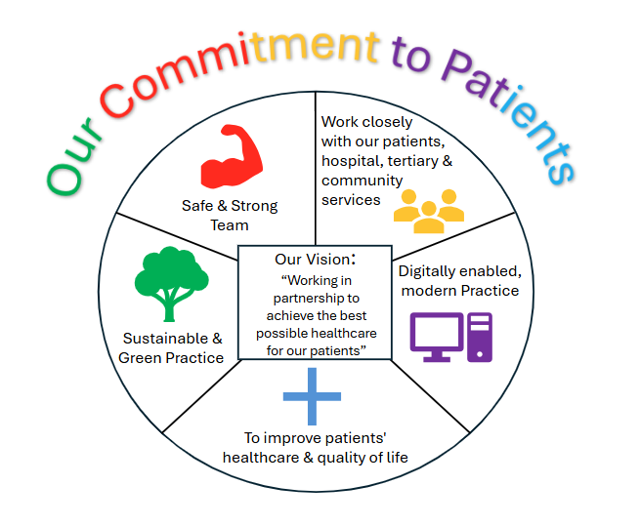

8. AOB All

Please leave a comment
Excellent GP visit, referred me for tests. Appointment for follow up tests came though in a timely manner, and little wait to have tests done. Thank you!
Very good
Friendly, caring, and reassuring
Very helpful consultation
Always so kind and caring, from making the call onwsrds
I interacted with the specialist pharmacist. She was thorough and knowledgeable.
Dr Mohammad is very clear, professional and inspires confidence. Thanks.
All members of staff live up to my expectations.
Nothing to improve on
Very helpful and caring.
It was punctual and competent
Efficient, professional service by reception & nurse
Very knowledgeable health staff and interested in helping the patient to improve their wellbeing.
The visit was to check the effect of the cream on the skin . Unfortunately, the cream was not effective. The way forward was to schedule visit to dermatology. I am waiting for NHS notification for the date.
Dr Sarah Mohamed was extremely helpful in assisting me.
If they can see us seniors for 15 to 20 minutes, would be appreciated.
Dr Sarah is absolutely amazing have great time for everyone
Friendly, responsive reception staff. Prompt, efficient nurse appointment. Good follow up.
Always helpful, responsive and courteous - both doctors, nurses and admin staff b
Very good
As always, prompt and efficient.
Polite staff, able to book appointments on app, never a long wait to answer the phone.
Doctor's instant recognition of nature and severity of condition and immediatel issue of correct medication
Dr Emma Coore is absolutely brilliant at dealing with my mum. She always shows patience and compassion.
All done very professionally
Incredibly careful and sensible. The practice is exemplary
Very efficient, very clean. Nice staff. Thank you very much! Suggest you tell people that you can’t have a smear test when you’re on your period to save time and resources! Thank you
I attended for a blood test,blood is extracted from the arm by a needle inserted into a vein then sent for testing.
Always difficult to get an appointment, but the staff are so nice and helpful.
Seen early. Felt listened to
I went to check if i have allergy for mould, because i have simptoms, i got checked for blood pressure, chest breathing, and nosestrill with a device, i got prescribed a spray to my itchy nose. I am disappointed becsuse i didng get referred at least to other doctor to see if i have allergy or not. that was my point to go to gp🥺
Good service. Very good staff and very helpful
Increase the availability of appointments either by phone or better still in person
very prompt
Great experience
GP gave me time and listened
I had blood in my urine after running. That went on for week. I made an online appointment and dr. Andrew called me. I told him explicitly that I did not want camera in bladder investigation, nevertheless, the hospital called me and said they would do a ct scan(which is ok) and the camera investigation(not ok). Because of that they refused to do the ct scan. Dr Andrew has now closed the case as it seems. This is far from ok!!!
Very welcoming. Attend to you promptly.
Clearly had not read recent medical updates. Unable to answer a simple, but to me, important question. Eventually got back to me with a false answer easily evidenced by my records. Failed to take any responsibility.
Saw Dr Harry Wyatt. I was impressed by his expertise and willingness to have an intelligent evidence based and data driven discussion.
Competent, rogessional advice, from a GP that I had never met before, but was fully aware of my medical records - as well as on administrative implications related to my condition (cancer patient).
I was seen promptly and the issues I had were dealt with
I have had excellent care.
I thought this was a questionnaire about my recent visit to the Imaging Dept at St Mary's Hospital. Why the questions about Marylebone Health Centre? Confused.

Future meetings
3rd Aug, 14th Sept, 26th Oct and 7th Dec.
Practice website address: www.marylebonehealthcentre.co.uk
NHS North West London ICB NHS West and North London ICB | Health & Care Services
Central London Health Care (GP Federation MHC members of) www.centrallondonhealthcare.co

