MARYLEBONE HEALTH CENTRE
PATIENT PARTNERSHIP GROUP AGENDA
11th May 2026 6-8pm

1.Welcome Chair JM
Apologies & Chair’s introduction

2. Minutes of last meeting Chair

3. Matters Arising Chair

4. Practice update JC
a) Staff changes
C) Complaints and F and family March
D) Change to NWL ICB –see new link below

5. Stakeholders JM and BH

6. Immunisations plan SF

7. Event Planning and work plan for PPG 2026/2027 JM
Event 15th April/Newsletter
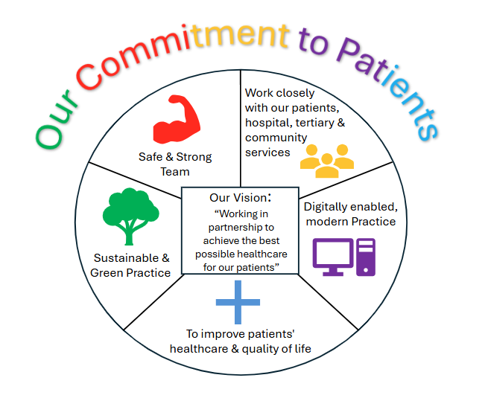

8. AOB All

Future meetings
22nd June, 3rd Aug, 14th Sept, 26th Oct and 7th Dec.
Practice website address: www.marylebonehealthcentre.co.uk
NHS North West London ICB NHS West and North London ICB | Health & Care Services
Central London Health Care (GP Federation MHC members of) www.centrallondonhealthcare.co

Patient comments -March 2026 Thank you for taking time to give us your feedback
I was seen quite quickly and my problem was discussed and advise was given.
Dr Yakub was amazing, brilliant communication style, reassured me at every step, very helpful in explaining details and super professional.
My appointment was for a blood test, I was seen promptly, and the procedure was painless and very quick.
I'm very happy with the service provided.
Lovely people in a beautiful location.
Difficult to see the same doctor
The surgery made the appointment which I attended. Neither they or I knew why I needed an appointment so the dr Kevin Patel having checked the system said I could leave
Nurse Karen and Francesca were very kind and reassuring when removing my stitches.
Perfect
Dr Mohammed, phoned me on time and was extremely kind and caring.! She asked me very relevant questions, and made an appointment to see me! Was very happy with call
Fantastic service from all staff
Not a visit, a message from one of the G Ps.
Excellent experience
Very prompt response
Feel very happy with outcome and care received
All good helpful advice and pleasant experience
The Doctor was very helpful and arranged a blood test.
Great very thorough and kind
Good
Very quick in and out
Dr Goodstone is very dedicated to his patients
No visit. Call from pharmacist, which was positive.
Very professional
She was very courteous
Seen on time very efficient
Was told I would sent a physiotherapy appointment but I wasn't.
Very friendly and eager to help.
Punctual appointment. Issues raised were dealt with promptly and kindly.
Practice is very good and appointment time was punctual and Dr. was very thorough
Very good and quick from emergency
It was good I went for a blood test which happened quickly
This practice is very good indeed. The Doctors, nurses & staff are all very professional & helpful at all times.
Pleased I was able to get an appointment within a short time.
I can’t think of anything that would improve the way I have been treated .Over the many years I’ve attended the practice. Always kind attentive and professional.
For me, every thing was excellent as usual, otherwise I wouldn't have stayed at the Marylebone health centre until today.
Oh so lovely and helpful arranging supply of medication for my long walk thank uou
Excellent consultation with surgeon
Reception staff, Doctors and Nurses are very good and helpful. They try their best to see the patients on time.
Appointment time largely taken up by repeating narrative of recent incident although there were full accounts in medical reports already received.

