MARYLEBONE HEALTH CENTRE
PATIENT PARTNERSHIP GROUP AGENDA
16th Feb 2026 6-8pm
Virtual Only Meeting

1.Welcome Chair JM
Apologies & Chair’s introduction

2. Minutes of last meeting Chair

3. Matters Arising Chair

4. Practice update JC
a) Staff changes
B) event feedback
C) Friends and Family feedback-dec 2025
35 F and F responses in Jan 2026
6 good experience 28 very good experience 1 neither good nor poor -see below
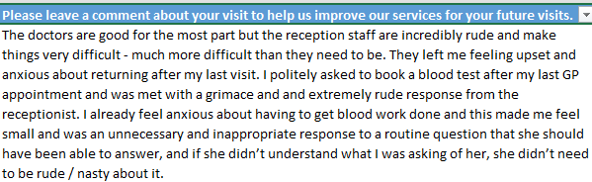

5. Stakeholders JM
Tuesday, 27 January 2026 HCL meeting – feedback from JM
N.A.P.P dissolution

6. Centre Review JC
Feedback from Jim/Yvonne and Judith

7. MHC strategy - see second page
Question for PPG- How can PPG help us deliver our strategy?

8. AOB All

Future meetings
30th March, 11th May, 22nd June, 3rd Aug, 14th Sept, 26th Oct and 7th Dec.
Practice website address: www.marylebonehealthcentre.co.uk
NHS North West London North West London – North West London Critical Care Network (londonccn.nhs.uk)
Central London Health Care (GP Federation MHC members of) www.centrallondonhealthcare.co

Marylebone HEALTH CENTRE

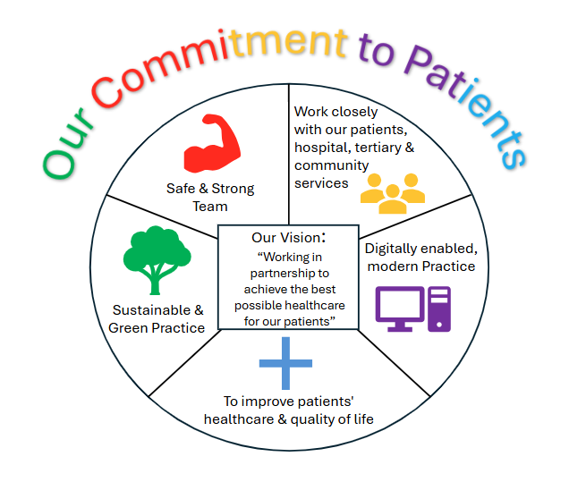
Some examples of what we do to deliver our strategy
Safe and Strong Team- keeping staff safe, team training, staff well being, good communication. Very safe recruitment processes.

Work closely with our patients, hospital, tertiary and community services
Patients- PPG and monthly pt feedback. Jim attends our staff interviews and Yvonne screens the newsletter
Hospital- use REGO and other communication tools, attend local monthly pead team meetings, high intensity user work
Tertiary- meet with the palliative care team monthly to discuss patients who are end of life
Community- regular meetings with the district Nurses and community matron –monthly shared case reviews and all new doctors spend a day with them on community visits

Digital enabled modern practice –we are a paper light surgery and all records from other NHS services are send directly to us. We have long term condition registers held on our IT system and we can monitor patients needs, we use PATCHs and Emails/Texts to communicate with patients/external parties and vice versa. Staff use teams for meetings and on line training. We use the latest public health dashboards so we can monitor our performance against others and up to date GP referral systems so we can refer/communicate with external systems easily.

Sustainable and green practice- We are a paper light surgery. All our paper waste is recycled although confidential waste is shredded x3 and then recycled. Staff use their own cups and mugs and we do not use disposable kitchenware. We recycle needles and sharps through NHS systems. We recycle our toners, send all correspondence via email where we can. In some areas we have lights which only turn on when we are using the space and turn off automatically when we leave the space. We create scrap out of non confidential paper and old envelopes. We sue bamboo cups for patients drinking water.

